

K. R Mangalam UNIVERSITY
ASSINGNMENT

SEMESTER— 2

Topic:-
FOUNDATIONS AND ALGORITHEMIC
ANALYSIS

COURSE—
B.TECH CSE-AI & Robotics

Subject:-DATA STRUCTURE

ROLL NO. –2501630020
SECTION:-A

SUBMITTED BY :- Rakshit Rathour
SUBMITTED TO :- ARTI

Part A: Stack ADT (ADT + Operations) Code:
v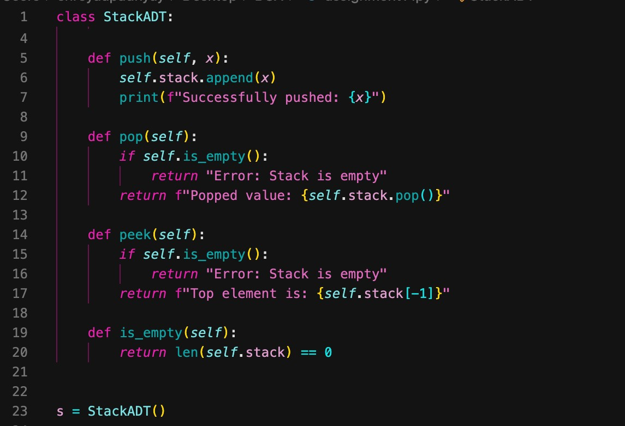

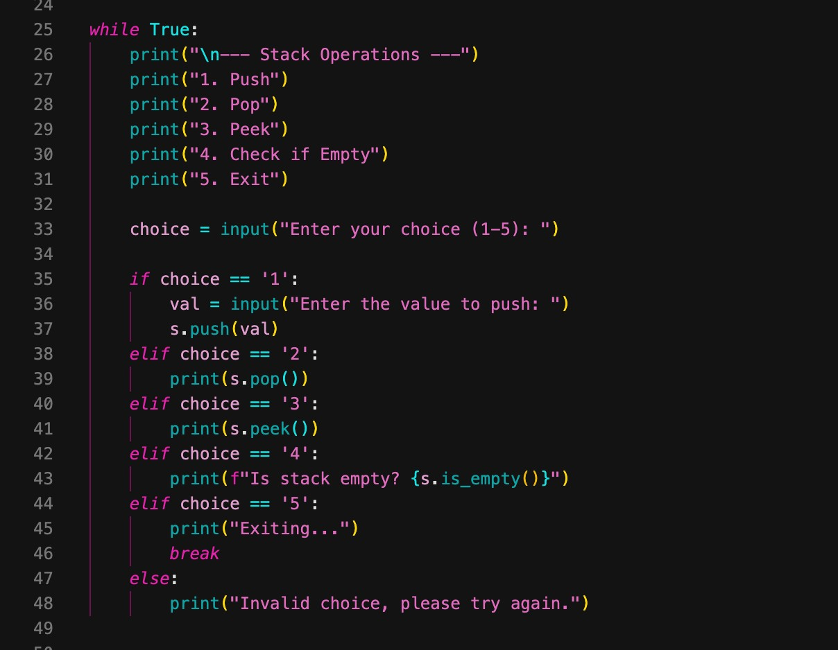

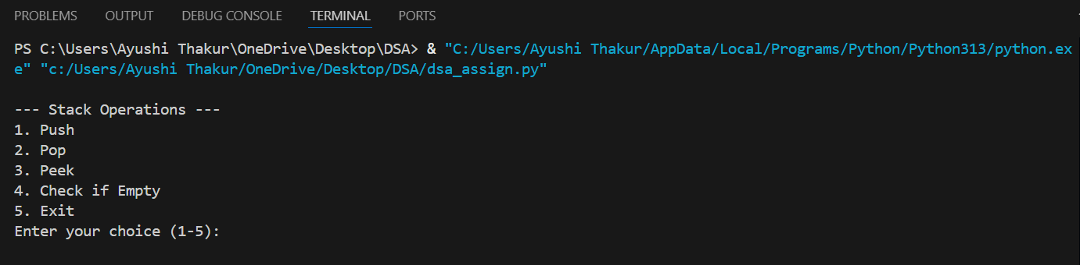

Part B: Factorial & Fibonacci (Recursion + Complexity) Code:

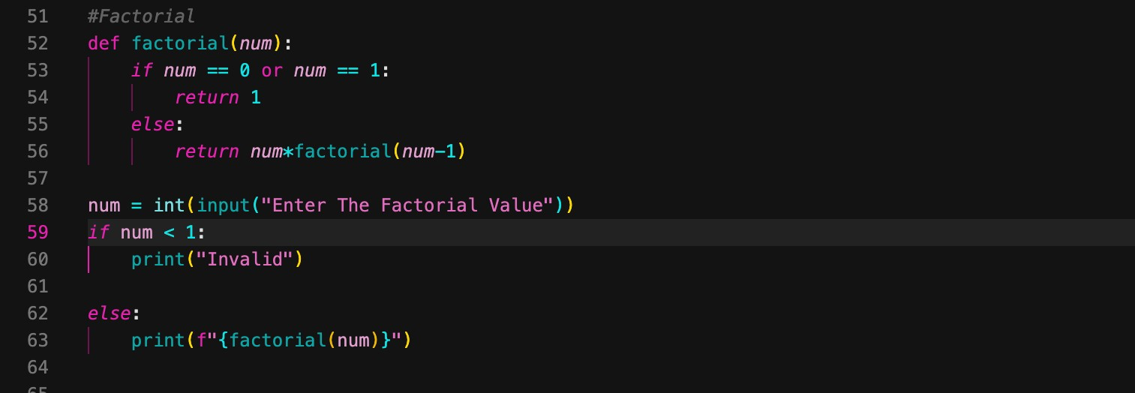

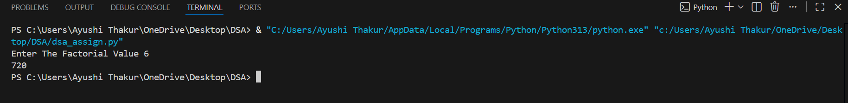

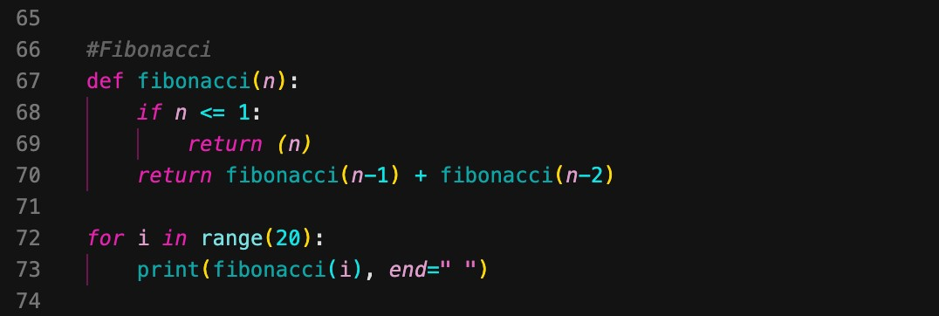

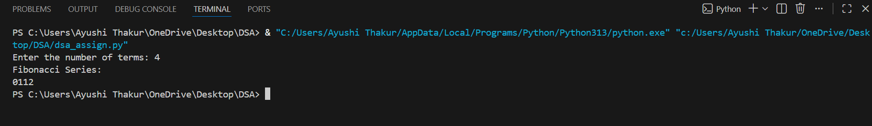

Part C:

Code:
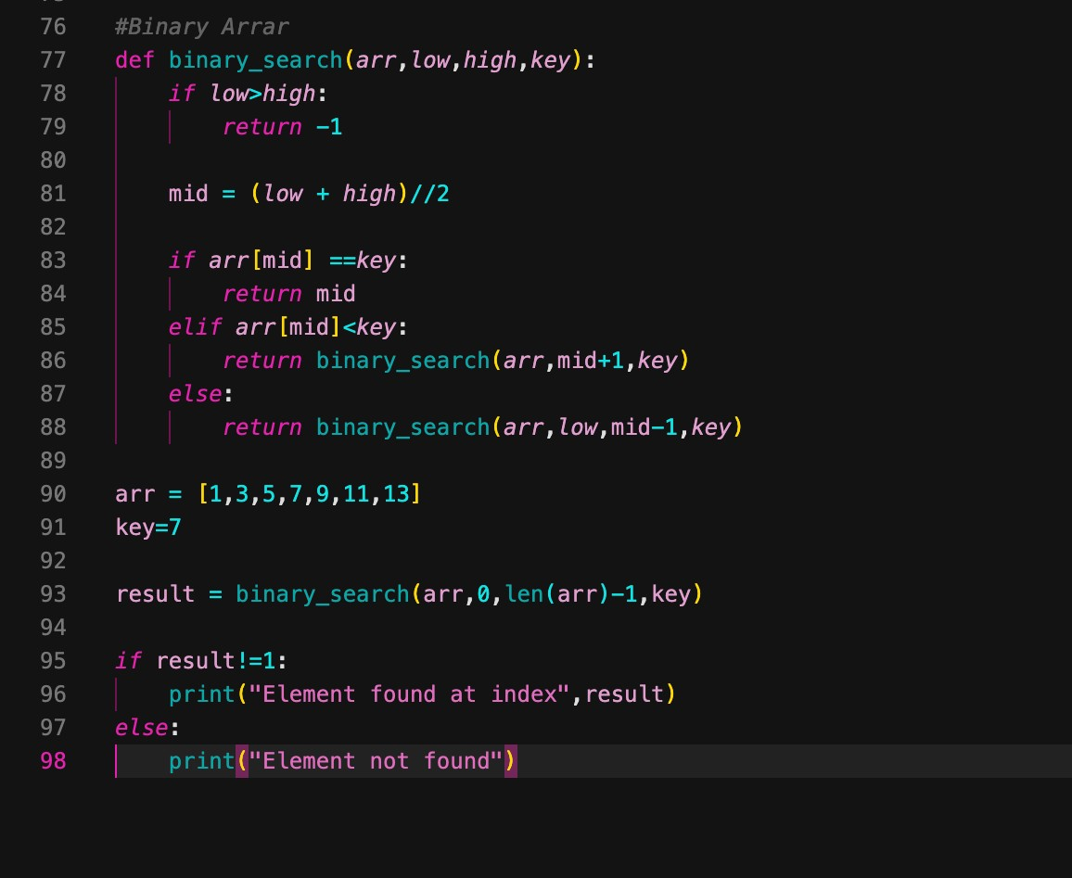
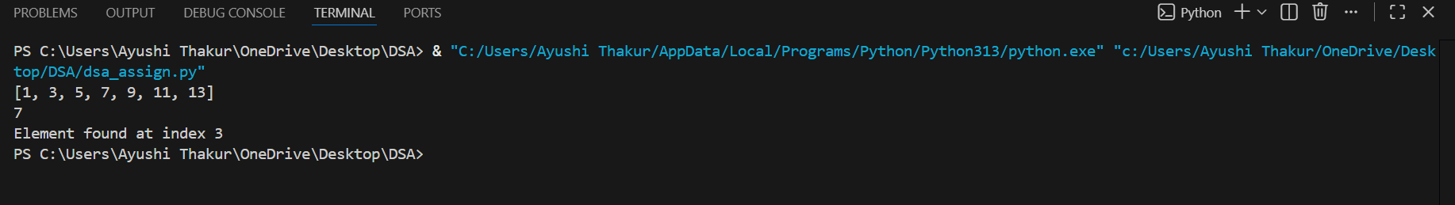

GITHUB LINK:
https://github.com/rakshitrathour2006-dev/DSA-Assignment_01/tree/main

